SMART MONITORING SYSTEM FOR PHYSIOTHERAPEUTIC PATIENTS ACTIVITIY

Anusuya Manickavasagam1 & Kesavan Sridharan1

Muni Ranjan1 & Pradeep Kumar1

Tian Jing1 & Chua Chin Heng Matthew1

Received:

Published online:

# Springer …

**Abstract:** The regular exercise prescribed by doctors and physiotherapists helps the patients in giving movement for the intended body part and helps in patient’s recovery. There are several types of exercises like push-ups, lifting of hand, bends and sit-downs that are suggested by the doctors. The major challenges in the recovery of the patient is continuity of exercise. While the patient tends to follow the routine in early days, it is normally scales down by manifold as the day progresses. This impacts the overall recovery time as well as a long-term gain of performing the exercise regularly. In a scarce medical industry, it is necessary to provide an end to end solution to be able to help patient meet their goals while maintaining the cost low. In this paper, we have developed and end to end working prototype which demonstrates the solution to this problem. This solution monitors the patient’s activities on trained model deployed at internal hosted servers and a portable small board deployed in the room for exercise which will capture the movements, masked the user identity and send the data to internal servers for prediction and other data management. An admin dashboard is developed to manage the overall patient and activities workflow. To summarize, the key considerations about this solution is running on a portable CPU board, maintaining the privacy for customers, accuracy of the model built on trained videos. The activity performed by the patient is then classified into the different exercise category. The different exercises achieved by the patients are monitored and verified if daily goals are achieved. Our preliminary experiments show an accuracy nearly 100% in controlled environment. We utilized the capability of the Hidden Markov Model(HMM) which is a statistical Markov model in which the system being modelled is assumed to be a Markov process with unobserved states. The HMM classifies the features engineered in live streamed video derived from their frame summaries, into different exercise categories in the background subtracted format thereby sending the results to the server.

---------------------------

Anusuya Manickavasagam

[E0146864@u.nus.edu](mailto:E0146864@u.nus.edu)

Kesavan Sridharan

[e0146771@u.nus.edu](mailto:e0146771@u.nus.edu)

Muni Ranjan

e0146946@u.nus.edu

Pradeep Kumar

[e0147017@u.nus.edu](mailto:e0147017@u.nus.edu)

Tian Jing

tianjing@nus.edu.sg

Chua Chin Heng Matthew

isscchm@nus.edu.sg

1Institute of Systems Science, National University of Singapore, Singapore 119615, Singapore

The results are then monitored by use of dashboard. Using the opencv and Python capabilities and harnessing the power of HMM we were able to achieve the classification of the different exercises performed by the patients with desirable accuracy. The doctor or physiotherapists can monitor the patient’s progress and advise the patient for future steps. This paper highlights the health-oriented monitoring using tools such as opencv and Python which aids in deploying an analytical engine. The prediction model is achieved with desirable accuracy thereby aiding the doctors to have a realistic system and give suitable prognosis.

Keywords: Physiotherapeutic Patients; Classification; Frame Sequencing; Exercise; HMM

**1 Introduction**

Patients who have been advised by doctors for any form of Physiotherapies will need to follow the pattern rigorously. When the exercises are proposed, initially the patients try to follow them, then eventually forget. We aimed our study to find a solution. Our experiments consisted of extracting the patients exercises and monitoring them in a controlled environment. These physical exercises aim to encourage movement and improve functional outcome. Early introduction, increasing complexity and regular supervision are regarded to provide superior results. 2, 1 We aim to build a system wherein the doctors or Physiotherapists can monitor the patients who are at home or any controlled environment without affecting their privacy. Poor adherence has been recognised across many healthcare disciplines including physiotherapy. 3,4,1 If the patients do not adhere to the prescribed regularity of exercises it may lead to spending more time and money for recovery.

Patients may undergo the exercises prescribed by the doctors in the controlled environment. This study does not require the patients to wear any external devices. Rather by use of Opencv and Python the skeleton framework of movements is captured through live streaming of a camera placed in the vicinity of the patient. Only the depth Image of the patients are captured thereby maintaining the privacy of the patients. The depth video stream is then sent to the analytical engine to do the classification of exercises done by the patient. To produce the summarization, we first generate a universal basis on which to project a video frame that effectively reduces any video to the same lighting conditions. Each frame is represented by a compressed chromaticity signature. Finally, we classify streamed videos using a trained Hidden Markov Model that utilizes the compressed array features of videos derived from their keyframe summaries (Cheng Lu, Mark S. Drew & James Au ,2003, Para 1). The results are then published on a dashboard visible to the doctors or physiotherapists and they are able to monitor if the patient achieved the daily target and hence advise them accordingly. For training the system, the team of four acted as volunteers and captured various exercise movements that a patient would be advised to perform. All these were done in a controlled environment.

# Methods and Materials

## **Video Capture**

The video recording was done using Intel RealSense camera and then converted into frames. Using opencv and Python capabilities the live streamed video was then converted to depth images (Background Subtracted) to avoid privacy issues. Based on multiple iterations, we decided to alter the size of the video to get superior prediction accuracy. The video recording and the conversion into depth images was done real time in the system. All our video recording and depth image conversion was done in a 2D setting. The video streamed was then sent to the Analytical Engine for further classification and prediction. The entire system has been built on the Intel RealSense board.

## **System Details**

### *2.2.1 Participants*

Four healthy Individuals (mean age of 30 4 years,with a range of 28-34 years) were used for the capture of video recording mimicking the various exercise poses required for our study (Vanessa Wei-Lin Mak,, Jin Huat Low,, Matthew Chin Heng Chua, Raye Chen Hua Yeow,2016, Page 3). All four individuals had volunteered for the process.

### *2.2.2 Procedure*

Subjects were asked to perform four basic exercises in a particular sequence and the video were captured. The images were then converted to depth images to protect privacy of the test subject. The depth converted images are available in Figure 1. The exercises comprise of A) Hand up down movement exercise B) Sit-ups C) Sideways bending D) Straight hand clock and anti-clock wise. All the video recordings were done on an average of 5 seconds5.

**Fig 1**: Images captured from the actual user

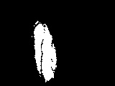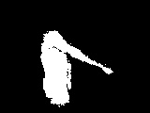

### *2.2.3. Analytical Engine*

To sequentially take the frame of images and classify them, we decided to build an analytical model using Hidden Markov Model(HMM).  Typical video segmentation algorithms classify shot boundaries by computing an image-based distance between adjacent frames and comparing this distance to fixed, manually determined thresholds. Motion and audio information is used separately. In contrast, the segmentation technique we have used allows features to be combined within the HMM framework6.

The use of HMMs in video event recognition takes two approaches: (1) to classify presegmented portions of video (e.g., by shot cut detection), as one of a defined number of classes, (2) to simultaneously, jointly parse and identify events within a continuous video stream. HMMs have been successfully applied in a small number of event recognition systems, in well-defined domains, where human motion is very constrained. Whenever the human motion in the events of interest is more natural and unconstrained, the use of HMMs is typically confined to simply classifying pre-segmented portions of video. This seeming reluctance to use HMMs for recognition means many potentially suitable applications miss out on the full power of the HMM framework. A greater understanding of the potential of the HMM can extend their application and hence avoid more complex multipass strategies commonly used for event recognition.7 In an HMM, there are a finite number of states and the HMM is always in one of those states. At each clock time, it enters a new state based on a transition probability distribution depending on the previous state. After a transition is made, an output symbol is generated based on a probability distribution, depending on the current state. In the formal definition of HMM, the hidden states are denoted Q {q , q , , q } = 1 2 … N , where N is the number of states and the observation symbols are denoted V {v , v ,.., v M } = 1 2 , where M is the number of observation symbols. The state transition probability distribution between states is represented by a matrix A = {a(i, j)} , where a(i, j) Pr(q at t 1 | q at t) = j + i , and the observation symbol probability distribution is represented by matrix B {b (k)} = j , where bj (k) is the probability of generating observation vk when the current state is qj . Initial state distribution denoted by = Pr( q at t = 1) π i contains the probabilities of the model being in every hidden state i at time t=1 that is the start point for a HMM. A HMM is always represented by λ = ( A, B,π ). (Cheng Lu, Mark S. Drew & James Au ,2003, Page 2).

After getting the live video stream, we extract the feature and train our HMM model. The HMM model itself is built utilizing the Python capabilities. The different exercises captured in the step 2.2.2 were used as dataset. The dataset is divided into training and test dataset. The video recognition was done using the Opencv capabilities of Python. The training videos are used with features extracted from RGB videos downsized to 100 sequential images (frames). For predicting the movement, same process is followed but features are extracted using the The images were then captured for the features using Feature Engineering. We have defined four classes for our training, 1. Hand movement 2. Sit ups 3. Side bending 4. Hand free movement. After each run, a .pkl file was generated. Then we tested the model using the test dataset. The test dataset was used to check if the model is classifying the videos into respective classes. The models were run multiple times with the desired frames to achieve higher rate of accuracy.

In a separate research, we experimented LSTM (Long Short Term Memory) Model to train our video datasets to do the classification. In LSTM we can input images as input as compared to HMM where we are doing feature engineering to extract desired features and hence do the prediction. LSTM would give better prediction as compared to HMM, since LSTM remembers values over arbitrary time intervals, we decided to use LSTM for video classification. But, desired performance constraint due to power of CPU board, the LSTM is not found to be technically feasible.

### *2.2.4 Monitoring System*

We have prototyped end to end system to implement the monitoring solution. (Figure 2). The Patient is live streamed from his home environment. The feed is then passed to the Analytical Engine which categorises to different exercises. This is in turn fed to the Node JS server which in turn retrieves the data from the database and feeds to the browser. The User/Doctor/Physiotherapist whenever they select a Patient profile from the dashboard can see the Patient’s exercise history for that category over the past selected day.

**Fig 2:** System Diagram

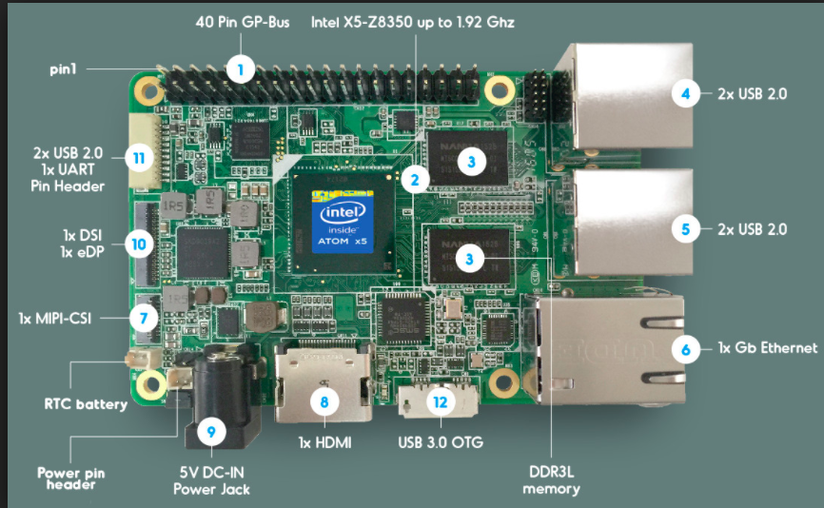

Registered on WIFI and mobile

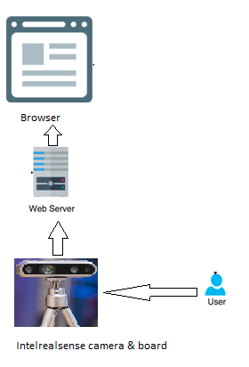

exercises done by the patient is monitored.

### *2.2.5 Dashboard*

We have built a Visual Monitoring System which would enable the doctors to see on a user-friendly user interface if the patient has done the prescribed exercise for that day. Figure 3 gives the screenshots of our Monitoring system.

The dashboard gives us the ability to add Patient name, set a goal to be completed by the patient (a goal can be frequency of a exercise), allows the user to add an activity and finally allows the user to track the activity. The dashboard can display historical data as well. While adding the exercise name precaution should be taken to add the same name as present in the analytical engine classifier.

From the analytical engine the feed is sent to the server and then it hits the SQLite database engine. The schematic layout of the database engine is explained in Figure 4. Post that, it connects with the user interface. Whenever a user selects a patient’s profile from the interface, the request is sent to the SQLite database and then to the server and then the required information is retrieved. The dashboard can display historical data as well.

The entire user interface is flow is displayed in Figure 5.

**Fig 3.1:** User Interface to add patient **Fig 3.2:** User Interface to add goal

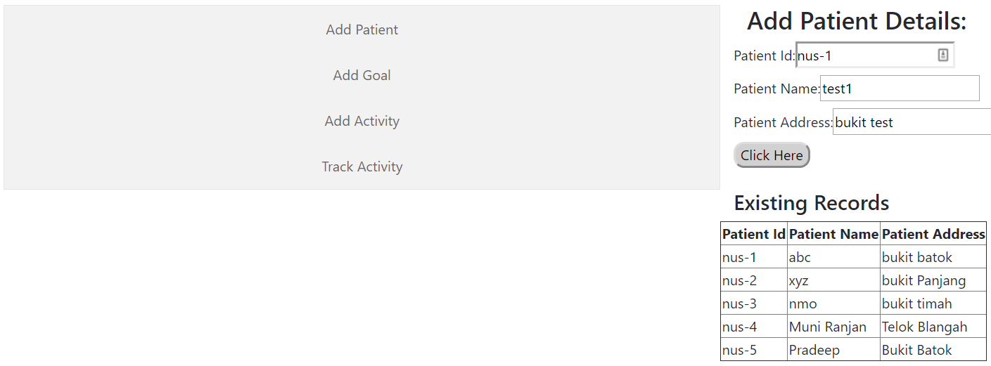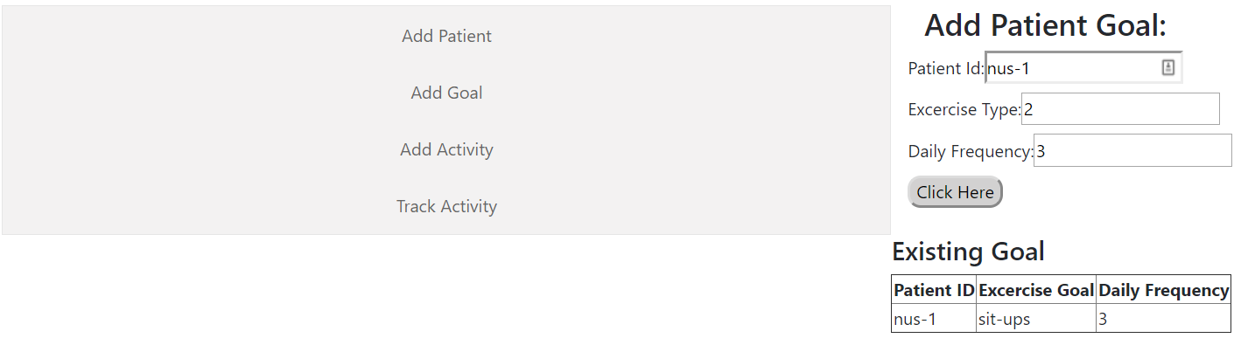

**Fig 3.3**: User Interface to add activity **Fig 3.4:** User Interface to Track Progress

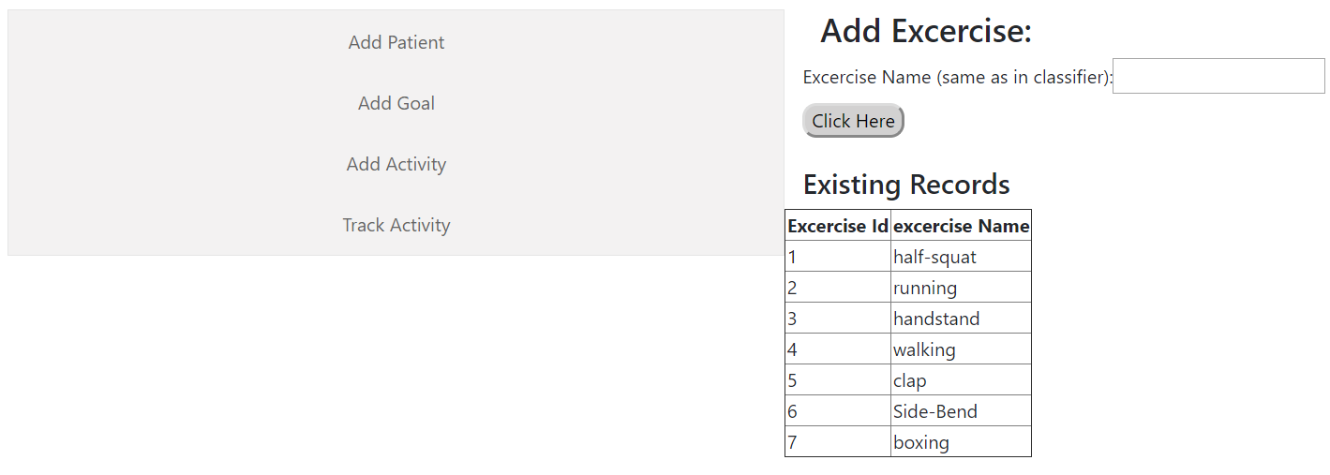 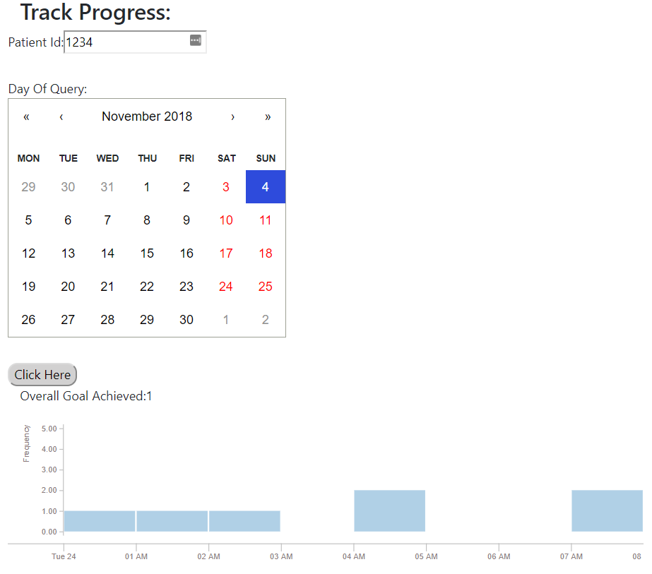

**Fig 4**: Database engine

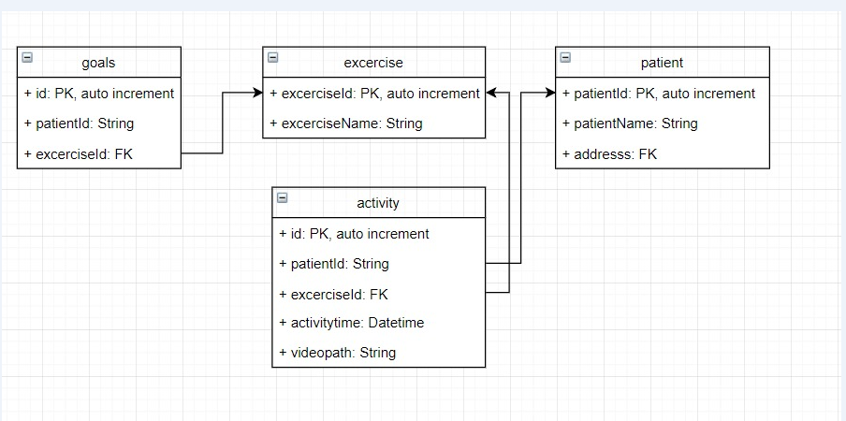

**Fig 5:** Use Case Flow

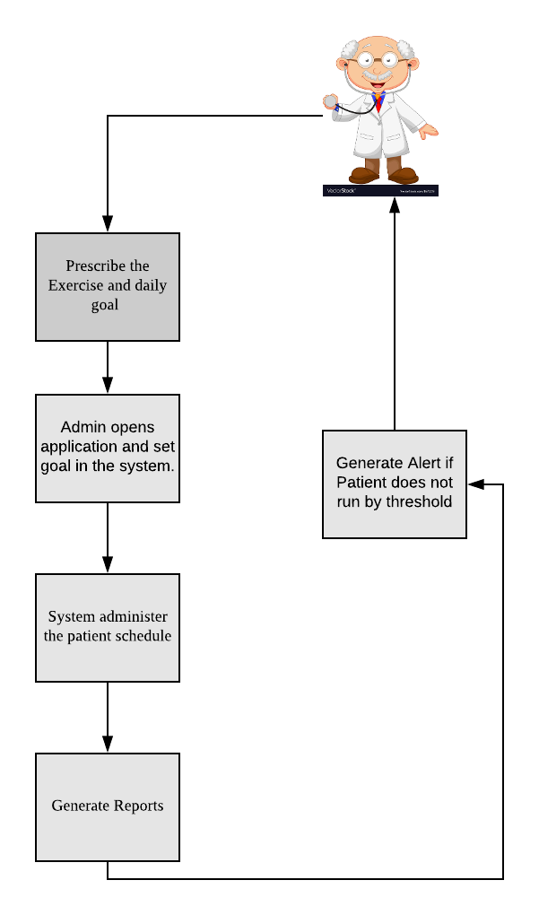

## **Data Building**

For building our prototype, we have replicated various exercises and built our system. Using the limited video dataset, we were able to train and test our model using HMM. Since, our dataset was limited we were able to achieve 100% accuracy in our predictions.

### *Results*

By achieving desired accuracy, we were able to classify the videos into the respective classes of exercise. We have developed an end to end system that helps us send instant alert to the user in case of not achieving the threshold. Our end to end system enables users/doctors to monitor their patients in their home environment and advise them accordingly. This pattern of intermediate user intervention helps in quicker recovery for the patients.

Our accuracy achieved was----------------------------------------

### *Limitations:*

All our experiments were done in a controlled environment. If we need to do perform monitoring in an uncontrolled environment, then further enhancement needs to be done. Specific exercises were trained and tested for this model. In order to enhance further to accommodate more exercises we will need to further train our model for classes. The dataset used for classification was limited thereby enabling to achieve 100% accuracy. When the size of our dataset is increased we will be able to understand the accuracy and build further upon it.

## **References**

1. A[bhishek Vaish](https://www.ncbi.nlm.nih.gov/pubmed/?term=Vaish%20A%5BAuthor%5D&cauthor=true&cauthor_uid=28360491),[Saif Ahmed](https://www.ncbi.nlm.nih.gov/pubmed/?term=Ahmed%20S%5BAuthor%5D&cauthor=true&cauthor_uid=28360491), [Anan Shetty](https://www.ncbi.nlm.nih.gov/pubmed/?term=Shetty%20A%5BAuthor%5D&cauthor=true&cauthor_uid=28360491). Remote physiotherapy monitoring using the novel D+R Therapy iPhone application. Retrieved from <https://www.ncbi.nlm.nih.gov/pmc/articles/PMC5359516/#bib0060>
2. Ferrari S., Vanti C., O’Reilly C. Clinical presentation and physiotherapy treatment of 4 patients with low back pain and isthmic spondylolisthesis. J Chiropr Med. 2012;11(June (2)):94–103. Retrieved from <https://www.ncbi.nlm.nih.gov/pubmed/23204952>
3. Friedrich M., Gittler G., Halberstadt Y., Cermak T., Heiller I. Combined exercise and motivation program: effect on the compliance and level of disability of patients with chronic low back pain: a randomized controlled trial. Arch Phys Med Rehabil. 1998;79(5):475–487. Retrieved from <https://www.ncbi.nlm.nih.gov/pubmed/9596385>
4. Campbell R., Evans M., Tucker M., Quilty B., Dieppe P., Donovan J. Why don’t patients do their exercises? Understanding non-compliance with physiotherapy in patients with osteoarthritis of the knee. J Epidemiol Community Health. 2001;55(2):132–138. Retrieved from <https://www.ncbi.nlm.nih.gov/pubmed/11154253>
5. Vanessa Wei-Lin Mak1, Jin Huat Low1, Matthew Chin Heng Chua1 and Raye Chen Hua Yeow. Effects of visual feedback on motion mimicry ability during video-based rehabilitation. Retrieved from https://www.cogentoa.com/article/10.1080/2331205X.2016.1215284
6. [J.S. Boreczky](https://ieeexplore.ieee.org/search/searchresult.jsp?searchWithin=%22First%20Name%22:%22J.S.%22&searchWithin=%22Last%20Name%22:%22Boreczky%22&newsearch=true); [L.D. Wilcox](https://ieeexplore.ieee.org/search/searchresult.jsp?searchWithin=%22First%20Name%22:%22L.D.%22&searchWithin=%22Last%20Name%22:%22Wilcox%22&newsearch=true). A hidden Markov model framework for video segmentation using audio and image features. Retrieved from <https://ieeexplore.ieee.org/document/679697/authors>
7. Naomi Harte, Daire Lennon,Anil Kokaram. On Parsing Visual Sequences with the Hidden Markov Model. Retrieved from https://jivp-eurasipjournals.springeropen.com/articles/10.1155/2009/924287
8. Cheng Lu, Mark S. Drew & James Au (2003) An Automatic Video Classification System Based on a Combination of HMM and VideoSummarization, International Journal of Smart Engineering System Design, 5:1, 33-45, DOI: [10.1080/10255810305039](https://doi.org/10.1080/10255810305039)